Heart of Michigan Officials Association
Umpire Clinic 2026
When: March 21st 9:00 Check-in Finish approximately 2:30
Where: Central Montcalm High School Gym 1480 S Sheridan Rd, Stanton
Who: MHSAA registered baseball and softball officials

Instructors: Joe Davis, Dave Cuthrell, Rollie Carman, John Sandlin, Doug Mascho
Classroom, batting cage, infield work. Bring full plate gear. Lunch provided

Baseball Classroom session 9:30-11:30 Gym session 12:30-2:30
Softball Gym session 9:30-11:30 Classroom session 12:30-2:30
Lunchtime speaker MHSAA Assistant Director Brad Bush

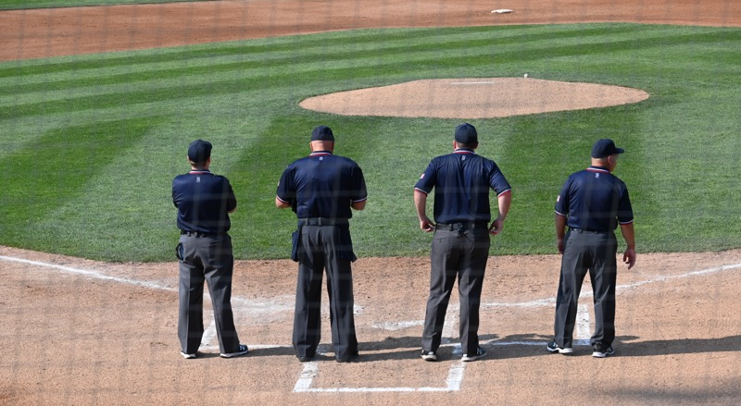

Please pre-register with Joe Davis maizenblue.jd14@gmail.com Include your name, cell number, email, sport, and experience.

