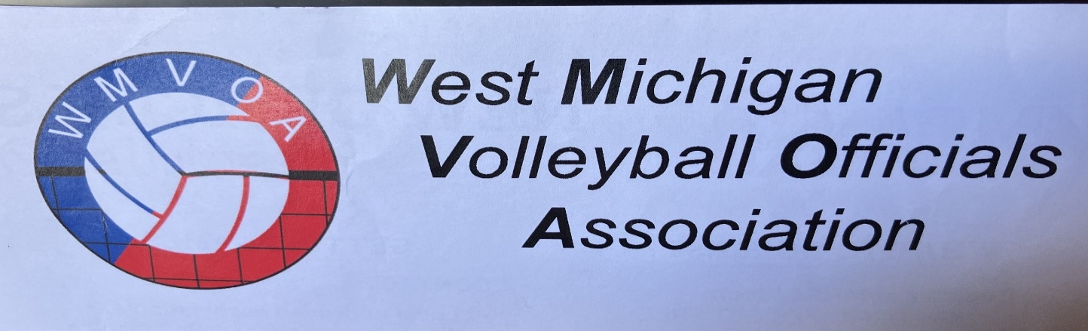

The West Michigan Volleyball Officials Association is pleased to announce that they will again be holding annual training camps in 2026. The two camps will be held at Aquinas College on consecutive Fridays - July 10 and July 17, 2026. WMVOA is excited that these camps have been so well received over the past dozen years and were ecstatic when over seventy officials registered in 2025.

Whether you are new to officiating or are a seasoned veteran, experienced clinicians will tailor personalized classroom training and one-on-one on court mentoring to your skillset. There is no better way to learn volleyball officiating than by being on the court with strong mentors/trainers there to lead you.

Areas of concentration in will include methods on how to:

- Enhance skills at the most difficult position - the R2.
- Continue to learn directions and tips to navigate the new 2025 ball handling rules.
- Learn tricks to increase your confidence in dealing with tough coaches, and how to "speak" through cards.
- Earn confidence in scoring by learning how to understand and do it, obtain tools to make corrections to fix issues when they occur, and most importantly learn to teach it – all necessities for any successful official.
- Establish efficient methods for identifying and correcting errors.
- Develop tricks to help identify back-row and libero faults.
- Gain confidence in learning how to master overlaps, and catch out-of-position faults; and
- Many, many more…

The costs are modest and include a full day of mentoring, along with free water and a free lunch.

Please visit the URL presented below to take you to the updated WMVOA website. Once there go to the training tab at the top to register for one of the WMVOA training clinics. https://sites.google.com/view/wmvoa/home?authuser=0.

If you have any questions, please reach out to me via email at Nearbj@att.net.

Betty J. Near
West Michigan Volleyball Officials Association (WMVOA) Training Chair
616.304.2216

