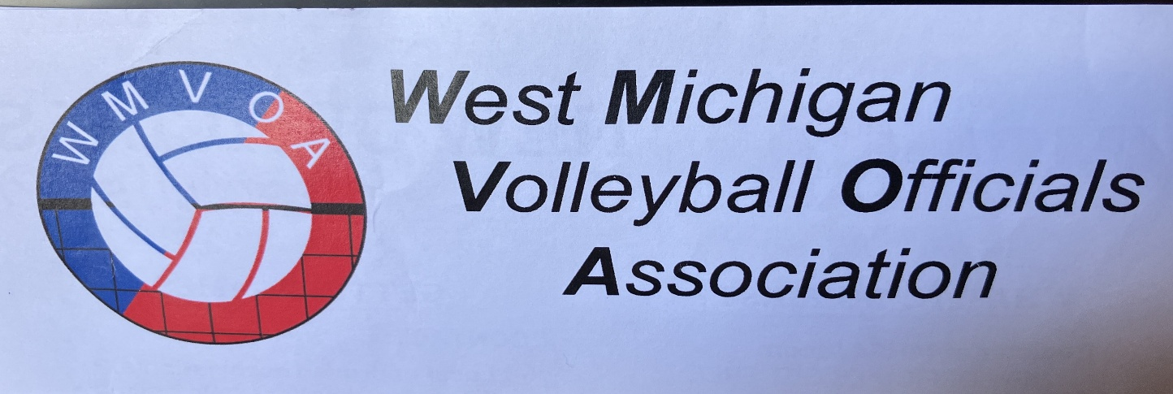

The West Michigan Volleyball Officials Association is pleased to announce that they will again be holding annual training camps in 2025. The two camps will be held at Aquinas College on two consecutive Fridays - July 11 and July 18, 2025. WMVOA is excited that these camps have been successful for years and were ecstatic when seventy officials registered to attend in 2024.

Experienced clinicians offer personalized classroom training and one-on-one mentoring, catering to both beginners and seasoned veterans. We are fortunate to be able to use high-level high school varsity tournaments to create an ideal environment for a full day of training and learning for attendees. There is no better way to learn volleyball officiating that being on the court with strong mentors/trainers there to lead you.

Areas of concentration in the classroom setting will include methods on how to:

- Enhance skills at the most difficult position - the R2.
- Use your onsite administrator to resolve crowd situations.
- Obtain insight on navigation of the new 2025 rule eliminating doubles on the second contact from experienced collegiate officials that faced this change last fall.
- Learn tricks to increase your confidence in dealing with tough coaches, and how to "speak" through cards.
- Develop proficiency in scorekeeping, acquire the skills to instruct others, and establish efficient methods for identifying and correcting errors.
- Develop tricks to help identify back-row and libero faults.
- Gain confidence in learning how to master overlaps, and catch out-of-position faults; and
- Many, many more…

There will be opportunities for questions, both in the classroom and on the court, so be sure to bring them with you. Also, if you have experienced troublesome situations please share your experiences with me ahead of time at Nearbj@att.net so we can include it in the classroom discussion.
Your investment will be $50 for members of the WMVOA, and $60 for non-members for an entire day of learning and mentoring; plus, your lunch will be on us.

Please go to the Training Section at https://wmvoa.com/ for further details and to register.

Questions may be directed to Betty J. Near at 616.304.2216.

